**A Report on**

**subject based Mini Project**

**Title: AI BASED VIDEO SURVEILLANCE SYSTEM**

**as a requirement of partial fulfillment of term work in Python Programming, submitted by**

1. **Pradnyesh Patil.**
2. **Omkar Khedkar.**
3. **Makarand Sawant**

**Under the guidance of**

**Dr. Rajkumar V. Patil**



**Department of Computer Engineering in Data Science**

**Saraswati College of Engineering, Kharghar,**

**Navi Mumbai**

**April 2023**

**Title of the Mini Project: AI BASED VIDEO SURVEILLANCE SYSTEM**

**Problem Statement:**

The current video surveillance systems rely on human operators to monitor the footage and detect any suspicious activities, which can be tedious, time-consuming, and prone to errors. To overcome this limitation, there is a need for an AI-based video surveillance system that can automatically detect and alert the security personnel about any potential threats, such as intruders, suspicious behavior, or objects left unattended, in real-time.

**Basic concept applied to address the problem:**

* An AI-based video surveillance system is a sophisticated technology that uses advanced algorithms to analyze video footage captured by surveillance cameras in real-time.
* AI-based video surveillance systems can help improve situational awareness, enhance operational efficiency, and reduce risks and losses of life and property
* With the rapid advancements in AI and computer vision technology, these systems are becoming more sophisticated and effective, providing greater accuracy and faster response times.
* The system uses computer vision, machine learning, and deep learning techniques to detect, track, and recognize objects, people, and events.
* However, there are also concerns about privacy and data protection, as the technology can collect and analyze vast amounts of personal information

**Code**:

import cv2, time

from datetime  import datetime

import argparse

import os

face_casacde=cv2.CascadeClassifier("haarcascade_frontalface_default.xml")

video = cv2.VideoCapture(0)

while True:

    check,frame=video.read()

    if frame is not None:

        gray=cv2.cvtColor(frame,cv2.COLOR_BGR2GRAY)

        faces = face_casacde.detectMultiScale(gray,scaleFactor=1.1,minNeighbors=10)

        for x,y,w,h in faces:

            img=cv2.rectangle(frame,(x,y),(x+w,y+h),(0,255,0),3)

            exact_time=datetime.now().strftime('%Y-%b-%d-%H-%S-%f')

            cv2.imwrite("face detected"+str(exact_time)+".jpg",img)

        cv2.imshow("home surv",frame)

        key=cv2.waitKey(1)

        if key==ord('q'):

            ap=argparse.ArgumentParser()

            ap.add_argument("-ext","--extension",required=False,default='jpg')

            ap.add_argument("-o","--output",required=False,default='output.mp4')

            args=vars(ap.parse_args())

            dir_path='.'

            ext=args['extension']

            output=args['output']

            images=[]

          for f in os.listdir(dir_path):

                if f.endswith(ext):

                    images.append(f)

            image_path=os.path.join(dir_path,images[0])

            frame=cv2.imread(image_path)

            height,width,channels=frame.shape

          forcc=cv2.VideoWriter_fourcc(*'mp4v')

            out=cv2.VideoWriter(output,forcc,5.0,(width,height))

            for image in images:

                image_path=os.path.join(dir_path,image)

                frame=cv2.imread(image_path)

                out.write(frame)

            break

video.release()

cv2.destroyAllWindows

**Project Output:**

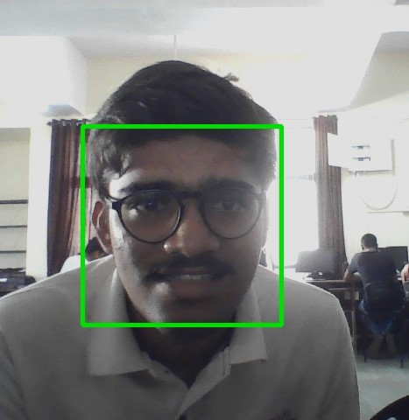

**Conclusion:**

In conclusion, live video surveillance systems are an effective tool for enhancing security in various settings, but they must be deployed and operated in compliance with legal and ethical standards to balance security and privacy concerns. With proper planning and implementation, these systems can create safer environments for individuals and communities.By capturing and analyzing real-time video footage, these systems can provide timely alerts and evidence that can help prevent and solve crimes.

**References:**

* 1]"An overview of intelligent video surveillance systems" by R.R. goudar et al. (2021)
* 2]"Real time video surveillance system using deep learning and GPU acceleration" by Y. Wang et al. (2020)
* 3]"Deep learning based intelligent video surveillance system for anomaly detection" by Y.chen et al.(2020)